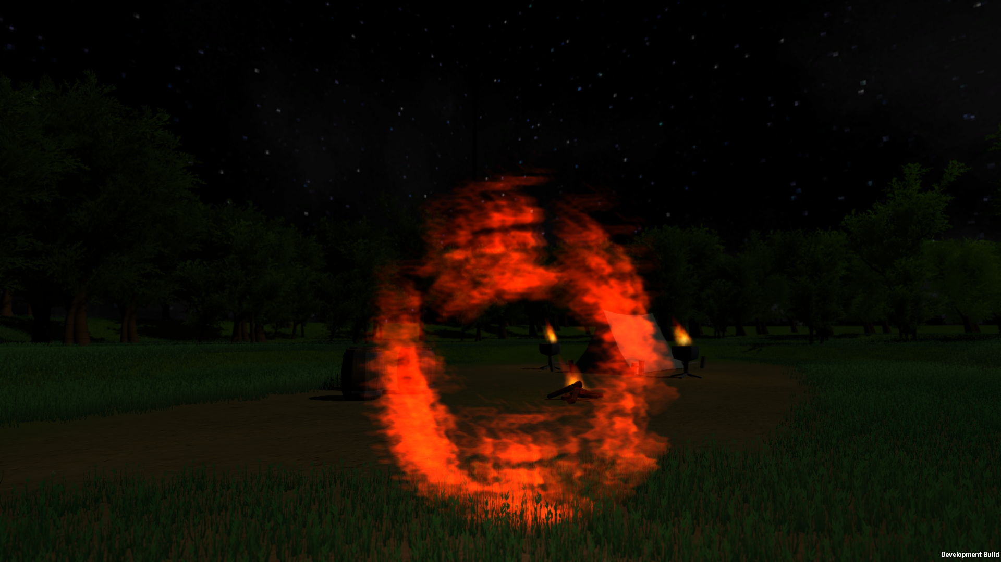

Level Design Report

B00235610

William Taylor | 3D Level Design | 10/01/2017

Table of Contents

Design 3

Narrative description 3

Settings, Theme, Location 3

Setting 3

Theme 3

Location 3

Player Experiencce 3

Level Features 4

Realistic Terrain 4

Clues 4

Loot 4

Enemies 4

Usability 4

PC Controls 4

Gamepad Controls 4

Video Research 4

HDR 4

Motion Blur 4

Depth of Field 4

Inspiration 5

Story 5

Game Story 5

Level Story 5

Interactivity 5

Objectives 5

Obstacles 5

Set Pieces/Scripted Events 5

Visual Development 5

Style Reference 5

Colour Palette 5

Lighting 5

Top-Down Layout and concept art 5

Level Layout 5

Screenshots 6

Engine 6

Originality 6

Project Planning and Control 7

Project plan 7

Duration, Start and End dates 7

Tasks and sub-tasks 7

Allocation of tasks 7

Gantt chart 7

Process description 7

Playtesting 8

Method 8

Outcomes 8

Survey Template 8

Expected Results 8

# Design

The level that will be designed will be from the game Scholar, a first person magic quest game that takes places in a unique environment. The following section of the report sets out the general theme and setting of the game and the level.

## Narrative description

You play as ‘’The Traveller” a nameless entity that is travelling across the Kingdom of Dalriada to its capital Kilcreggan. In your possession is the ‘Tome’ a scripture filled with cryptic symbols that effect the world once articulated. Your quest is to take the valuable scripture to a safe haven where it can be studied for the better of the wider kingdom. The question that must be answered though, can you master the Tome’s secrets in order to achieve your goals, can you effectively wield its power to protect you.

## Settings, Theme, Location

### Setting

As alluded to in the narrative description the level is set in the Kingdom of Dalriada in a period known as the Age of Discovery commonly referred to as the Second Age. The exact date is not known however it is set in the final days of the Second Age with the completion of the journey starting the Age of Knowledge or Third Age.

### Theme

The theme of the game is medieval fantasy taking various style elements from Celtic and Medieval history. The game’s theme encompasses large sprawling forests with small medieval towns that serve to give the game a unique look and theme. The theme is meant to entrance the player in its beauty while completely masking the dangers that lie around the player.

### Location

You start in an undisclosed forest in the Kingdom of Dalriada on the way to the nearest town. However, prior to the start of the level you understand that it is getting dark and you are on your way to a nearby campfire to sleep and rest. However, the campfire lies uninhabited except for one sole body laying by the fire. With suspicions raised you decided to investigate the fate of the occupants of the camp site.

## Player Experiencce

The player is due to arrive at a camp site in the near area. The player upon arriving will perform investigative work finding clues at the site to find out what happened. Once all clues have been revealed the player is supposed to successfully survey the area revealing a group of monsters that have been killing travellers through the area for a long time. The player will need to deploy their magic skills to defeat said enemies, once they have they can acquire loot for the future travels.

## Level Features

### Realistic Terrain

The level itself will be set in an open area in a forest. Do give the illusion that this is a real place the forest itself will be expansive comprising of various trees, bushes and general features.

### Clues

The campsite itself will have various clues about, to interact with said clues the user will press a button revealing an exposition dump to fill the player in on the narrative. Once all clues are revealed the story will continue showing the location to go to investigate further.

### Loot

The level will comprise of three loot locations. The first is loot contained under a bridge that must be crossed to get to the campsite. The second is at the campsite itself, there will be chests located next to one of the tents. Finally, there will be a chest located at the location where you kill the monsters which is meant to represent their spoils from their killing adventures.

### Enemies

Here are a list of enemies

## Usability

### PC Controls

Here are the pc controls

### Gamepad Controls

Here are the gamepad controls

## Video Research

Find references

### HDR

Here is the content

### Motion Blur

Here is the content

### Depth of Field

Real time dynamic lighting aided.

## Inspiration

Medieval RPGs that I used to play as a kid.

## Story

### Game Story

Here is the story. **(THIS)**

### Level Story

Here is the level story. **(THIS)**

## Interactivity

Playable elements, controls **(THIS)**

### Objectives

Here is the content. **(THIS)**

### Obstacles

Here is the content. **(THIS)**

### Set Pieces/Scripted Events

Here is the content. **(THIS)**

## Visual Development

Here is the content

### Style Reference

Here is the content

### Colour Palette

Here is the content

### Lighting

Here is the content

## Top-Down Layout and concept art

Drawing of level + pictures for demo scene

### Level Layout

Here is the content

### Screenshots

Here is the content

### Engine

Unity engine **(THIS)**

## Originality

Takes inspiration from many RPGs

# Project Planning and Control

Here is the content

## Project plan

Here is the content

## Duration, Start and End dates

Here is the content

## Tasks and sub-tasks

Here is the content

## Allocation of tasks

Here is the content

## Gantt chart

Here is the content

## Process description

Here is the content

# Playtesting

Here is the content

## Method

## Outcomes

## Survey Template

## Expected Results